# Arduino-based Optical Sensor Assembly Instructions

## Hardware Requirements

See the file [Parts List.xls](Parts%20List.xlsx) for details.

|  |  |
| --- | --- |
| **For Box containing Arduino Board** | |
| Magnet (standard circuit box mounting magnet) |  |
| Screw/nuts/washers for magnet:  2 M4 washers  2 nuts for 8-32  1 cap screw: 8-32, 1/2" Ln. |  |
| Box (2 1/16” x 3” x 5 ¼”) |  |
| 2 BNC connectors |  |
| Pre-crimped wires and their housings, cable ties  For top part:  4 x (4-40) screws  4 washers for #4 screws |  |
| electrical wire , heat shrink and pin strip |  |
| 4 aluminum standoffs (tapped) |  |
| Nylon screws (4) and spacers (16) |  |
| Arduino board + micro-usb adaptor + USB M-M cable | C:\Users\emanuele\Downloads\arduino USB cable.png |
| **Tools**   * deburring tool * micrometer * soldering station * wire stripping tool * cutter * pliers * heat gun |  |
| **For Optical Sensor** | |
| Infrared LED |  |
| 18 nylon spacers  4 nylon screws  2 nylon hex nuts |  |
| 39 Ohm Resistor |  |
| 2 metal ring connectors |  |
| optical flow sensor |  |
| Machined aluminum piece to hold sensor near the ball (L-shaped stand piece) |  |

## Arduino Box

Assembly steps:

1. Drill holes in box according to the instructions in the following Inventor files: part_top.pdf, part_bottom.pdf. Double check dimensions before drilling. After drillingDe-bur holes to eliminate jagged edges.
2. Install magnet: the configuration should be : [screw] – [washer] – [magnet] – [box] – [washer] – [nut] – [nut] (use two nuts to prevent future unscrewing of the screw).
3. Place hex standoffs on the 4 holes in the top part of the box and use the 4-40 metal screws + matching washers to fix them in place.
4. Place one plastic spacer on top of each standoff, Place Arduino board on top, and put 3 more spacers on top of each hole. Slide the nylon screws through the spacers until reaching the standoffs, then turn the screws until the board is held tight.

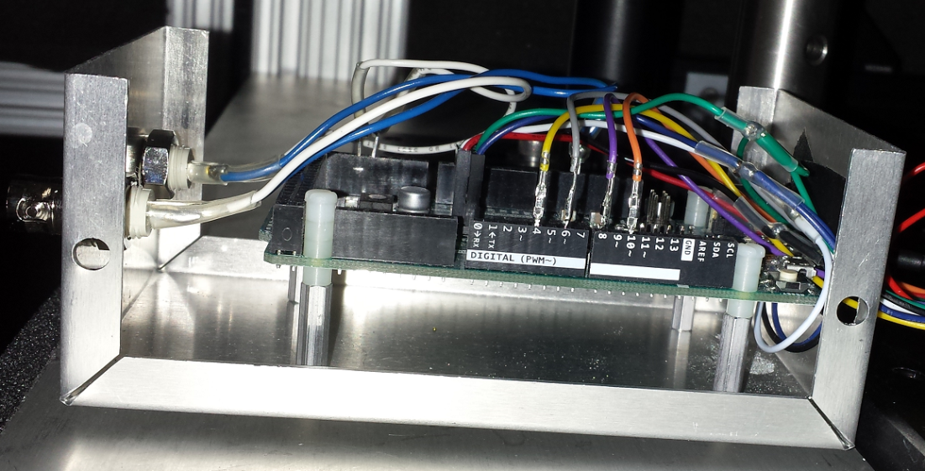

1. Cut and strip wires for BNC connectors, measured according to the diagram outlined in: Due_ADNS_connections_Dual_Sensor.pptx
2. Remove 3 pins from the pin-strip with the pliers. Solder one end of the two ground wires to one pin, and one end of each of the positive wires to a pin.
3. Solder the wires to the BNC connectors; cover each soldered contact with heat shrink.
4. Screw in BNC connectors into their slots. Connect BNC connectors at the appropriate pins according to: Due_ADNS_connections_Dual_Sensor.pptx
5. Preparing the pre-crimped cables: if using the single-sensor configuration, simply connect them with their housing according to the wiring diagram, no further soldering is necessary. If using the dual sensor configuration, proceed as follows:
   1. Prepare the 5 F-F split cables: each split cable is formed from 2 F-F cables. Take the first cable of the pair, and strip a short segment 2” away form 1 end. Cut of and strip the end of the pother cable. Now solder the cut end of the second cable to the stripped segment on the first cable. Cover with heat shrink (important!).

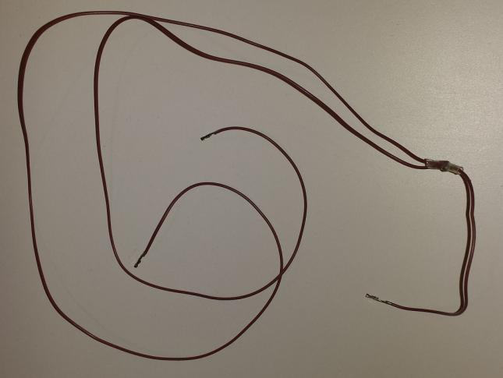

* 1. Connect the 5 F-F split cables and the 4 M-F stand-alone cables according to the wiring diagram using the appropriate housing.

1. Secure each wire bundle (all the wires that go to one sensor) with cable ties to avoid entanglement
2. Double check all connections.
3. Connect micro-usb adapter to micro-usb port closest to the power supply (programming port). Connect USB M-M cable to adapter on one side and to the computer that will communicate with the Arduino board on the other. Box can now be closed and placed in the setup.
4. Board should look like this:

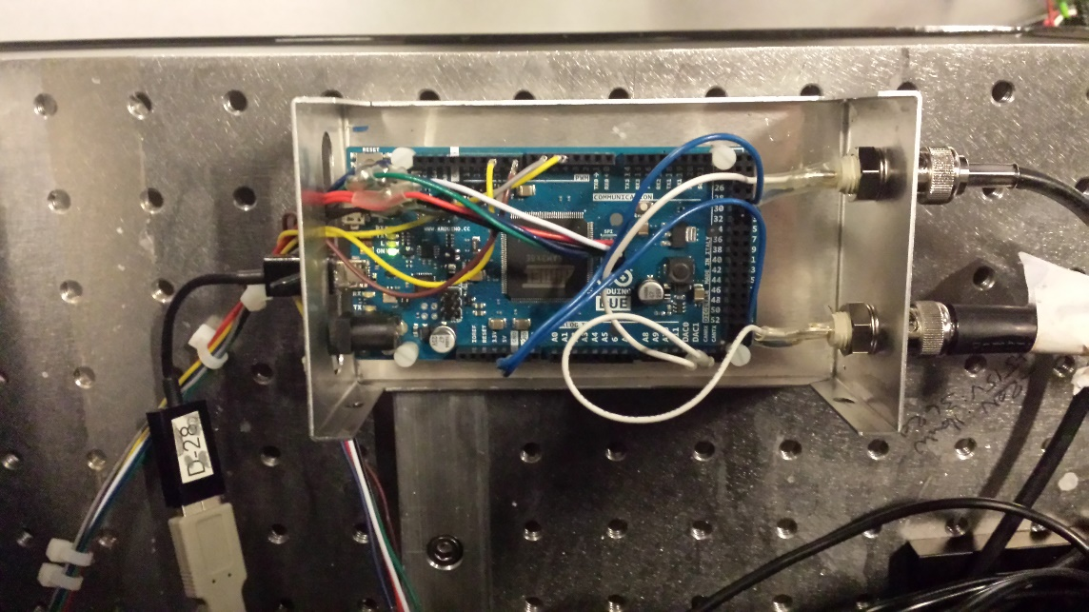

## Optical Flow Sensor

Assembly steps:

1. Solder the header to the sensor board (header is included when buying sensor).
2. Cut and strip 2 electrical wires, measured to go around the sensor once (see pictures). Solder all components according to the wiring diagram. The electrical path is as follows: [GND pin (board)]-[wire #1]-[ring connector]-[LED]-[ring connector]-[resistor]-[wire #2]-[5v pin (board)]. When soldering the wires to the board ideally do so on the board side rather than on the header side (to leave room for the cable coming from the Due).

## Secure ring connectors to the holes in the board near the camera in the following way: [nylon screw]-[spacer]-[board]-[3 spacers]-[ring connector]-[spacer]-[nut].

## C:\Users\emanuele\Downloads\sensor2.png

## Secure the board to the L-shaped stand using the two remaining holes in the board as follows: [nylon screw]-[spacer]-[board]-[3 spacers]-[stand].

## Connect the Due to the sensor board by sliding the pre-crimped cables (with their housing) on the appropriate pins in the header soldered to the board. Double check the connections.

## When assembled/soldered, the sensor + sensor mount should look something like this:

## C:\Users\emanuele\Downloads\sensor4.pngC:\Users\emanuele\Downloads\sensor1.png

## C:\Users\emanuele\Downloads\sensor3.png

## Two-Sensor System for 2D Treadmill

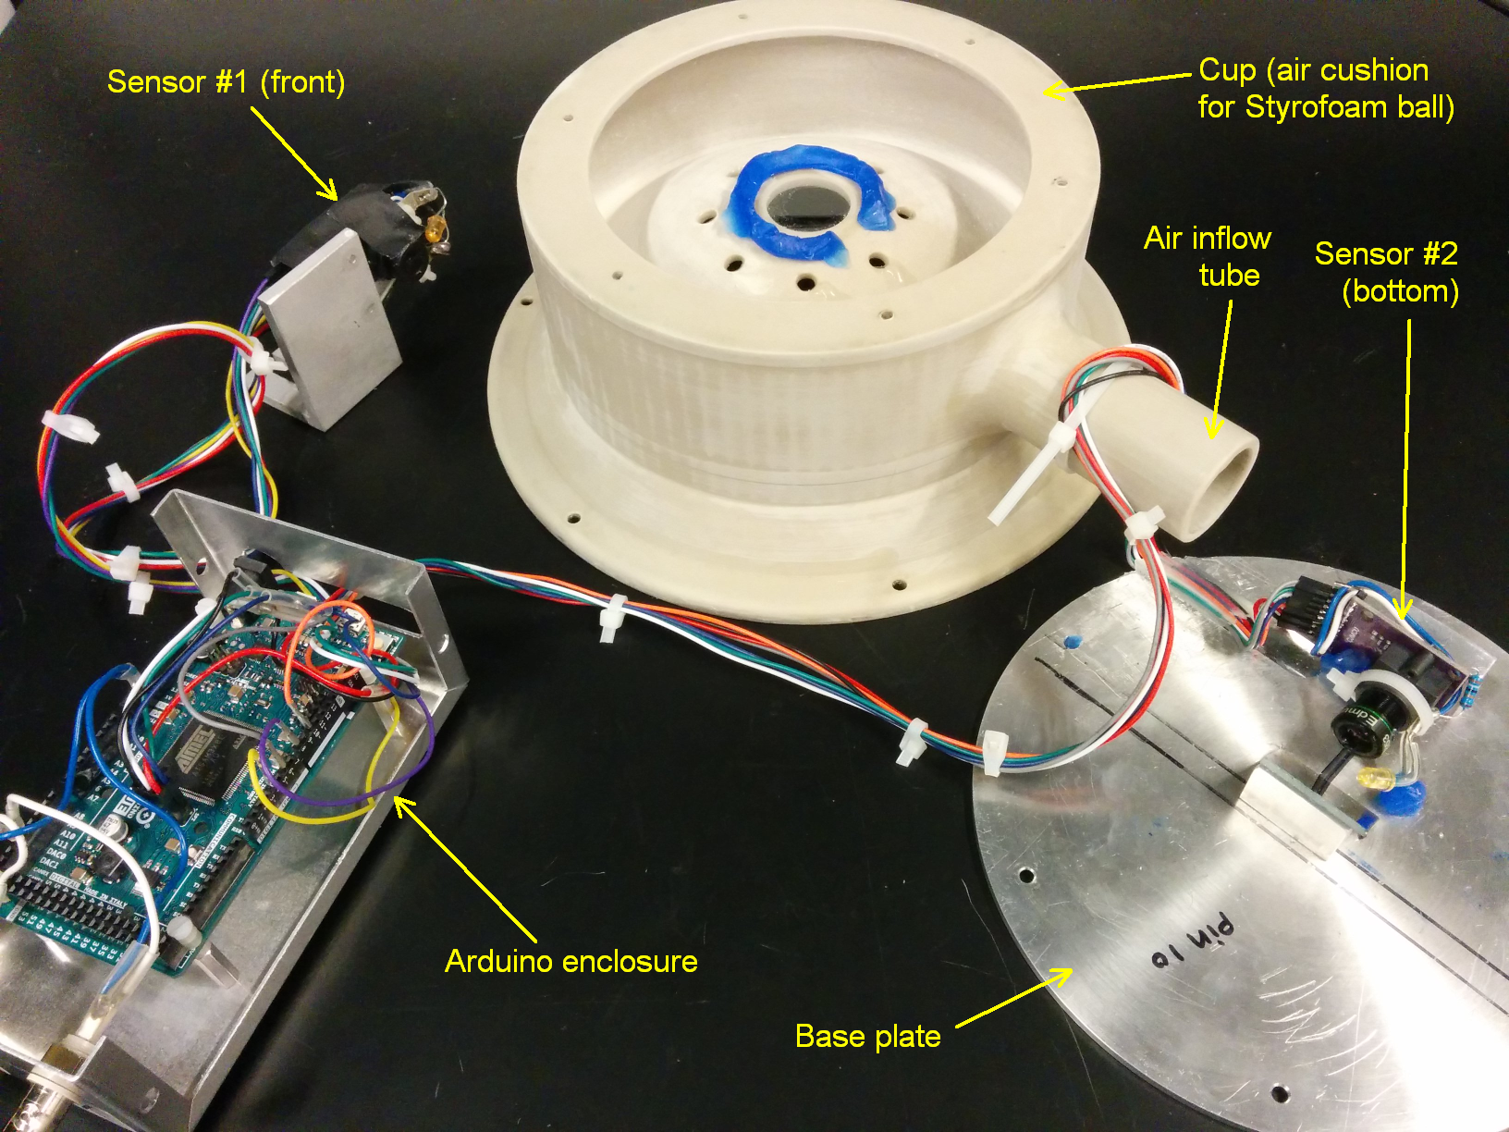

This section describes how to assemble an air support cup with an optical flow sensor that measures the displacement of the bottom of the Styrofoam ball. This design requires a cup with an open bottom and an aluminum base plate, to which the sensor is affixed.

1. Assemble optical flow sensor #2 in the same way as for sensor #1. The main thing to watch out for is that the wires connecting the resistor to the LED should be short and of equal lengths, so that they can be folded around the chip as seen in the photo above.

* There is very little clearance from the sensor chip to the parts of the cup that will be on top and at the back of the sensor.

1. Replace the f=4.2mm focal length lens in the M12 holder of the optical flow sensor chip with an f=8mm focal length lens (see [Parts List.xlsx](Parts%20List.xlsx)). The lens threads into the M12 mount and can just be rotated until it detaches.
2. Before attaching anything to the base plate, use a black marker to draw at least two reference lines as shown in the photo below.

* One line should be parallel to the tangent line of two screw holes. It will be used to align the mirror along the direction of lateral movement for the head-fixed mouse.
* The other reference line should be perpendicular to the first line, and bisect the base plate. It will be used to center the optical sensor lens along the direction of forward/backward movement for the head-fixed mouse.

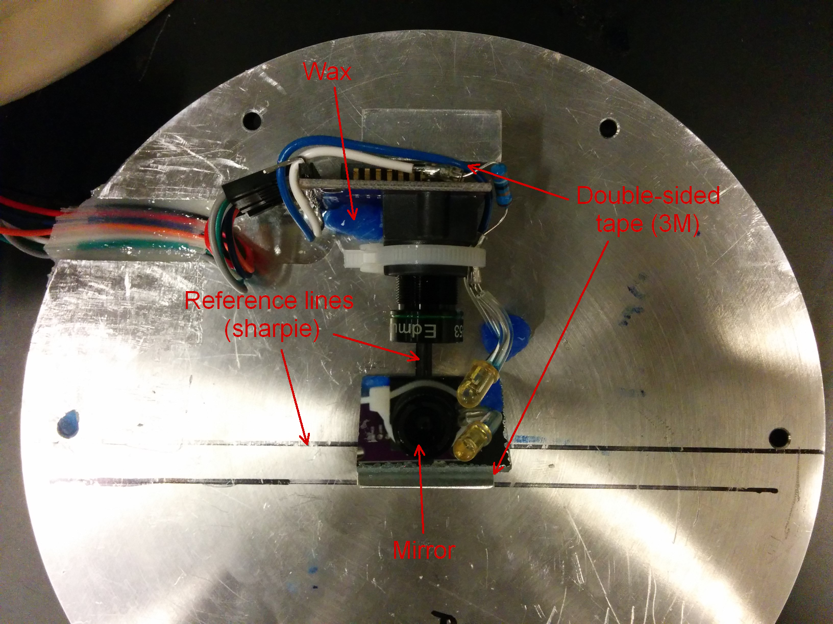

1. Attach the triangular aluminum mounting block for the mirror to the central hole using a low profile screw. Make sure that the edge is parallel to the first reference line.
2. Attach the rectangular aluminum mounting block for the sensor to the two screw holes facing the triangular mounting block. The second reference line should bisect this block.
3. Cut a roughly 1” by 1” piece of front-coated glass mirror using a diamond saw. Make sure to account for the thickness of the mirror so that when attached to the triangular mounting block, the top edge of the mirror is no higher than the edge of the mounting block. This is illustrated in the photo below.
4. Attach the mirror to the triangular mounting block using double-sided tape. 3M tape works well as it is very strong.

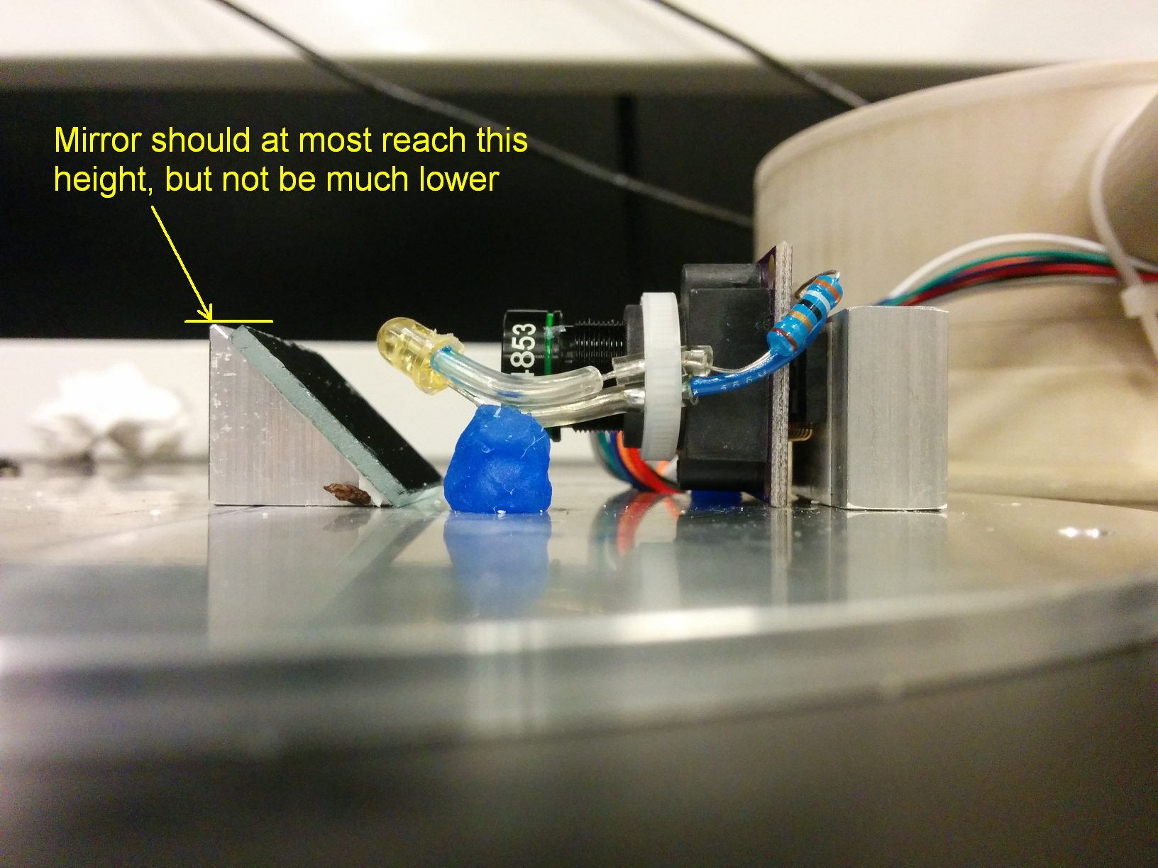

1. Use a piece of wax to fill the gap in between the M12 lens holder on the sensor chip so that it can rest on the base plate with the edge of the printed circuit board (PCB) flush with the base plate. This is indicated in the photo below and will help prevent sagging or accidental displacements of the sensor over time.
2. Attach the optical sensor to the rectangular mounting block using double-sided tape.
3. Attach the wires connecting the sensor to the Arduino board. Organize them so that they can lie flat within the groove in the base plate, as shown in the photo below. Hold the wires in place with paper tape outside of the region to which epoxy will be applied.
4. Put the base plate on a piece of paper to prevent accidentally epoxying it to the table.
5. Mix non-sagging 5 minute epoxy and apply it to the groove, making sure to cover the gap in between wires. Remove excess epoxy by running a razor blade over it, with the blade held perpendicular to the base plate. The epoxy should be as flush with the surface of the base plate (outside of the groove) as possible.
6. When the epoxy has dried, remove the paper tape. If needs be, excess epoxy can be chipped off.
7. Put the base plate upside down over the cup (which should itself be upside down), so that the back of the sensor mounting block faces the air inflow tube.
8. Attach the base plate to the cup using low profile screws. Be careful that the threads on the cup are very delicate – do not overtighten the screws, nor force them in!

